**Name- Rahul Kumar Section-KM107**

**Reg no: 11805446 Subject- INT246**

**Roll no-A20 CA- Project**

**Fuzzy Logic Control of Wind Energy System**

**Githhub:** [**https://github.com/Lovely-Professional-University-CSE/int-246-project-irahulkr**](https://github.com/Lovely-Professional-University-CSE/int-246-project-irahulkr)

**Fuzzy logic** is a basic control system that relies on the degrees of state of the input and the output depends on the state of the input and rate of change of this state. In other words, a fuzzy logic system works on the principle of assigning a particular output depending on the probability of the state of the input.

Fuzzy logic works on the concept of deciding the output based on assumptions. It works based on sets. Each set represents some linguistic variables defining the possible state of the output. Each possible state of the input and the degrees of change of the state are a part of the set, depending upon which the output is predicted. It works on the principle of If-else-the, i.e. If A AND B Then Z.

**Fuzzy Control System**

A fuzzy control system consists of the following components:

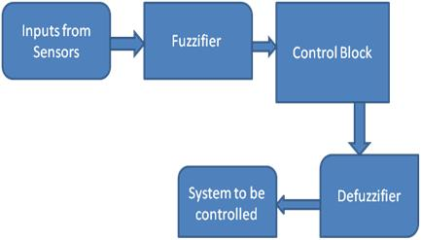

A Fuzzy Logic Control System

**A Fuzzifier** which transforms the measured or the input variables in numerical forms into linguistic variables.

**A Controller** performs the fuzzy logic operation of assigning the outputs based on the linguistic information. It performs approximate reasoning based on the human way of interpretation to achieve control logic. The controller consists of the knowledge base and the inference engine. The knowledge base consists of the membership functions and the fuzzy rules, which are obtained by knowledge of the system operation according to the environment.

**The Defuzzifier** converts this fuzzy output to the required output to control the system.

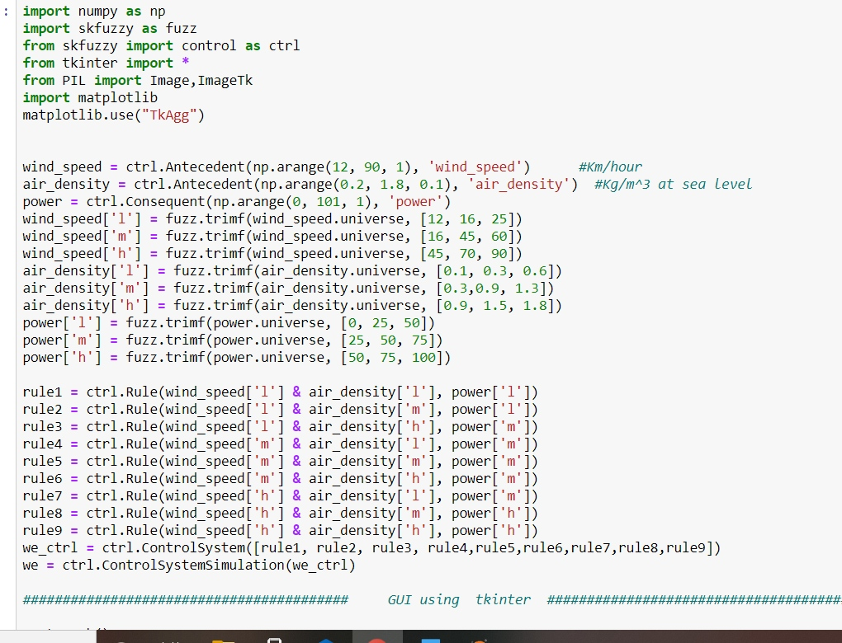

**Code for Fuzzy Logic Control of Wind Energy System**

